IISE Annual Conference & Expo 2018
Full Paper Formatting Guidelines

Congratulations on having an accepted abstract for the 2018 IISE Annual Conference & Expo! Thank you for your interest in submitting a full-length conference paper. Remember that accepted full papers will by copyrighted and indexed. In preparing your paper, please follow the following guidelines. We appreciate your contributions to the 2018 conference.

Please note that full manuscripts are reviewed using a double-blind process. Please use only the web conference management system-assigned abstract ID as the manuscript identifier, as shown below. Do not include any author data on the manuscript submitted for review, but do allocate sufficient space for author data in the submitted manuscript to meet the 6-page limit. The abstract ID should not appear in a final, accepted manuscript.

This text in red should be deleted prior to submission. If you have comments or questions about the following formatting guidelines, please contact the Program Chairs:

Kash Barker, University of Oklahoma – kashbarker@ou.edu
Diana Berry, Harsco Rail – dianapz@hotmail.com
Chase Rainwater, University of Arkansas – cer@uark.edu

-------------------------------------------------------------------------------------
Full Paper Title

Abstract ID: XXX

No Author 1 or 2 Yet
No Organization Yet
No Location Yet

No Author 3 Yet
No Organization Yet
No Location Yet

Abstract

All papers must include an Abstract. Begin with the word Abstract immediately following the title block with one blank line in between. Use centered, 12 point, Times New Roman Bold text for this heading. Use 10 point Times New Roman font for the text of the abstract. There should be a single blank line between the heading and this text. The abstract should be fully justified and consist of a single paragraph between 100 and 200 words (maximum of 200 words). The abstract must match the abstract submitted in XCD.

Keywords
Three to five keywords related to the main topic must be specified for all submissions. For example, Industrial engineering, operations research, stochastic processes

1. Paper Size
Your paper should be formatted for 8 1/2" by 11" US standard paper format.

2. Page Layout
All papers must follow the following layout:
- 8 1/2" x 11" paper
- Top and bottom margins: 1.00", left and right margins: 1.00"
- The first page header containing IISE 2018 editors information (The one in this template can be used for all papers)
- Header (from second page to end) containing the list of last names of the authors (In using this template, authors need to double-click the header in the second page and replace it with their names). Do this step only for an accepted manuscript on final submission.
- Single-spacing in a single column
- Full text justification
- No footers or page numbers
- No indentation - use a single blank line to separate paragraphs
- Maximum of 6 total pages (including author data, references, and any figures and tables).

3. Paper Title and Author Data (add author data only to an accepted manuscript)
The following information should be placed at the top of the first page:
- Paper title: 16 point Times New Roman bold, centered
- Author listing: 12 point Times New Roman, bold, centered author names; department or college; university or company; city, state and zip, country. Authors with the same affiliation must be grouped together on the same line with affiliation information following in a single block. An example is shown above.

4. Text Sections and Headings

4.1 Text Sections and Headings
Text should be organized into sections and subsections, with an Introduction and a Conclusions section being advisable. A single line should separate paragraphs; no indentation should be used. Font guidelines are as follows:
- Section Headings: Numbered, 12 point, bold, Upper and Lower Case, left-justified; leave one blank line above only.
- Section Sub-headings: Numbered, 10 point, bold, Upper and Lower Case, left-justified; leave one blank line above only.
- Regular text: 10 point Times New Roman, full justified, with a single line between paragraphs.

4.2 Bullets
Bullet guidelines are as follows:
- First level bullet.
- Second level bullet.
  - Third level bullet.

5. Figures, Tables, and Their Captions
Tables and figures should be included in the main text (see Figure 1 and Table 1), as close to the point of their introduction as possible. It is noted that figure and table numbering should be independent. Captions guidelines are as follows:

- Figure captions: 10 point Times New Roman, centered; place below the figure, leave one blank line above and below. For example, see Figure 1 below.
- Table caption: 10 point Times New Roman, centered; place above the table, leave one blank line above only. For example, see Table 1 below.

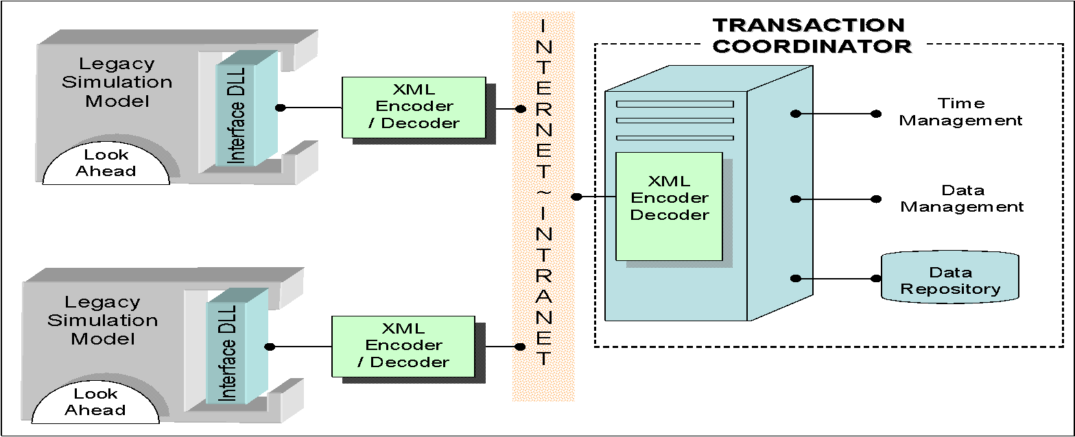

Figure 1: Example figure for demonstration

This is an example paragraph to demonstrate the guidelines for the figure and table captions.

Table 1: Example table for demonstration
 |  | Conservative | Epoch | Improvement (%)
Six epochs | Federation run time | 1.1 | 0.44 | 62.8
 | Number of time advance messages exchanged | 9470 | 1027 | 89.2
 | Number of checking messages exchanged | 34302 | 23533 | 31.4

6. Equations
Equations should be centered and numbered, with the number in parentheses, positioned flush to the right margin. Preferably, they should be prepared with an Equation Writer. See Equation (1) below for the demonstration.
(1)

7. Page Numbers
No page numbers should appear on the paper.

Acknowledgements
Acknowledgement of funding support and/or any other kind of assistance should be contained in an "Acknowledgements" section (this section should have no section number), located immediately before the "References" section. If the acknowledgements include or can be easily linked to the authors, then this information should not be included until final submission to ensure a double-blind review.

References and Citations from Texts
References should be numbered sequentially by order of occurrence in the text and listed in a separate section labeled References (this section should have no section number) at the end of the document. Within the text, they should be cited by the corresponding list number, which should be enclosed in brackets [1]. If you refer to two documents, use the following format [6, 7]. If you refer to more than three documents listed consecutively, use the format [5-8]. The following provides example formats for different types of reference documents.

References
- Son, Y., Wysk, R., and Jones, A., 2003, “Simulation Based Shop Floor Control: Formal Model, Model Generation and Control Interface,” IIE Transactions on Design and Manufacturing, 35(1), 29-48.
- Son, Y., and Venkateswaran, J., 2006, “Hierarchical Supply Chain Planning Architecture for Integrated Analysis of Stability and Performance,” International Journal of Simulation and Process Modeling (in press).
- Venkateswaran, J., and Son, Y., 2005, Production and Distribution Planning for Dynamic Supply Chains Using Multi-resolution Hybrid Models, Simulation (submitted).
- Venkateswaran, J., 2005, “Production and Distribution Planning for Dynamic Supply Chains using Multi-resolution Hybrid Models,” Ph.D. dissertation, The University of Arizona.
- Venkateswaran, J., and Son, Y., 2005, “Information Synchronization Effect on the Stability of Collaborative Supply Chain,” Proc. of the Winter Simulation Conference, December 4-7, Orlando, Florida, 1668-1676.
- Chang, T., Wysk, R., and Wang, H, 2006, Computer-Aided Manufacturing, 3rd Edition, Prentice Hall, New Jersey.
- Usher, J.M., 1999, “Chapter 9: STEP Standard in Design and Manufacturing,” appears in Direct Engineering: Toward Intelligent Manufacturing, Kamrani, A.K. and Sferro, P. (eds.), Kluwer Academic Publishers, Boston, 259-284.
- Rajgopal, J., and Needy, K.L., 2000, “Paper Submission Instructions for IERC 2001,” (15 August 2000).

